Installation of Muller Panda 2/ Tigra
Code QC-MU/PA-FP-6-01
30mm shafts with 80mm outer diameter creasing unit

Top shaft Bottom shaft
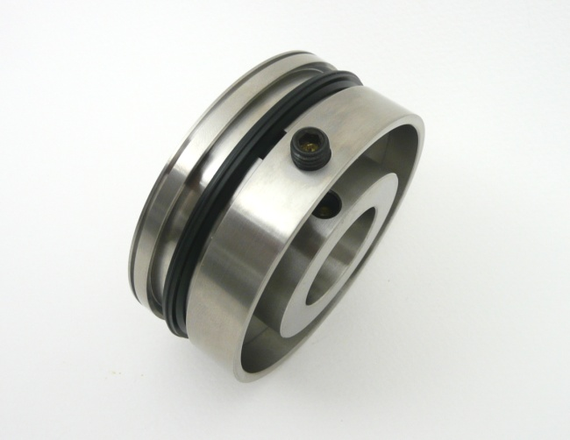
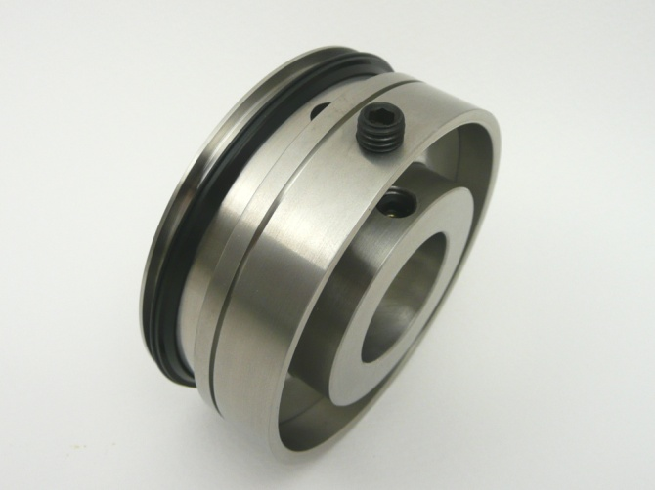

Top shaft Bottom shaft
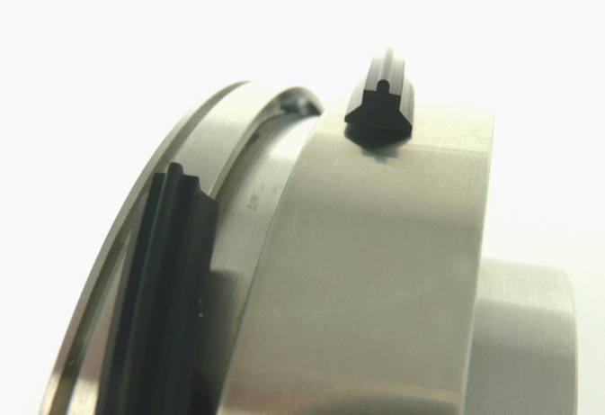
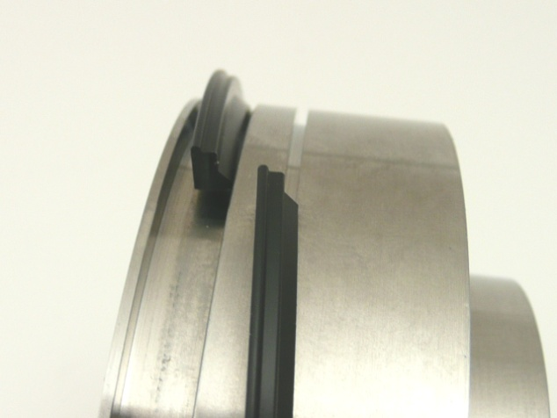
Uses a single wedge shaped crease rib Uses a double wedge shaped crease rib

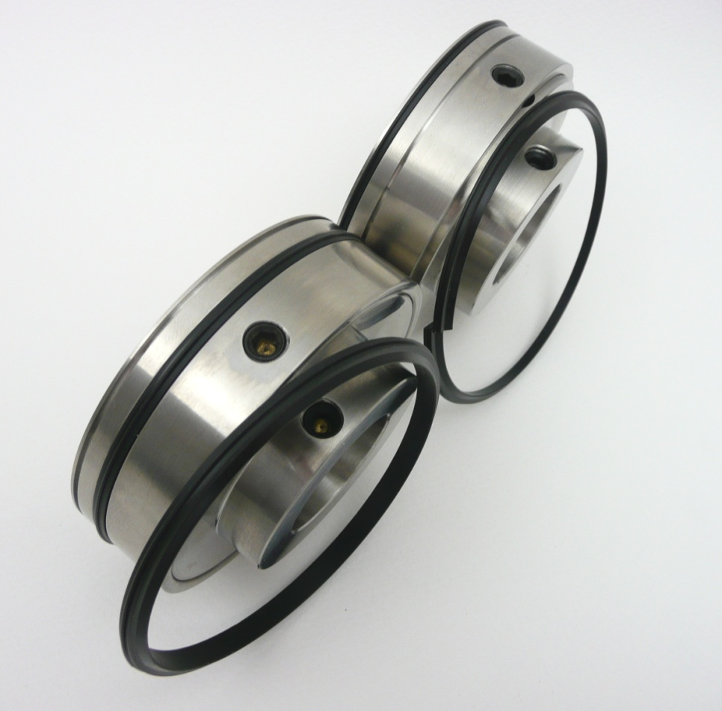
Top shaft single chamfered crease rib

Bottom shaft double chamfered crease rib

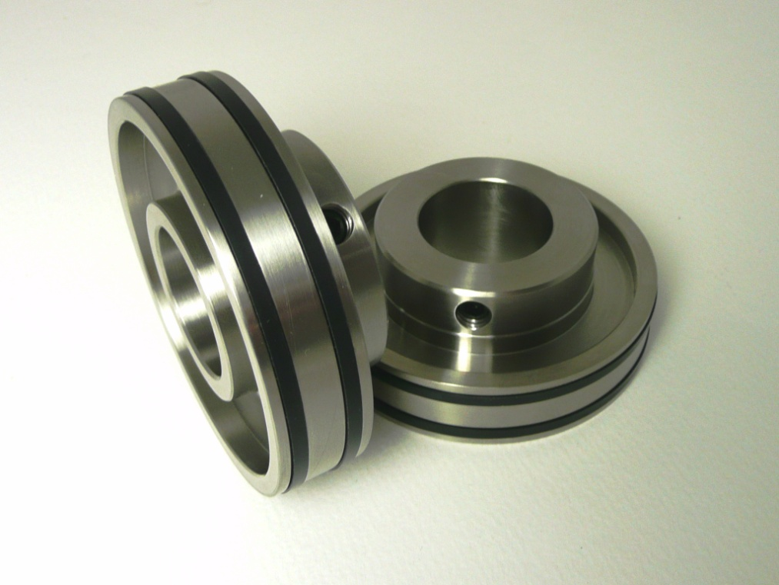
2 x Top Shaft Support Collars
Used to grip the sheets as the creases are applied

Aligning the Creasing units
With the crease ribs locked into the crease units, align the BOTTOM SHAFT crease units to the correct creasing position ( left side being aligned with the edge of the clamp ) and tighten the fixing screws
Slowly lower the top shaft crease units making sure the top nylon crease ribs locate into the female channel on the bottom crease unit.
DO NOT TIGHTEN TOP SHAFT FIXING SCREWS
Slowly run a sheet of cover stock through the Spine & Hinge units.
As the cover travels through the crease units the loose top crease units will automatically centralise to the optimum creasing position.
With the cover stock still gripped between the crease units tighten the fixing screws.
The machine is now ready to test.

OPTION NYLON CREASE RIBS
Remove the crease ribs from crease units before sliding on to the shafts as accidental damage to the crease ribs can occur during installation.
3 depths of crease can be obtained by using the 3 colour coded crease ribs as shown below. Each rib has a coloured dot on the inside of the crease rib.
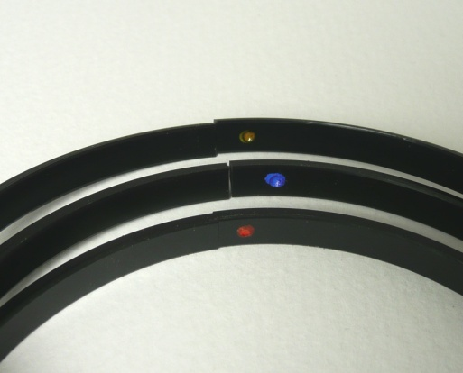

orange blue yellow
light medium heavy

